**Lab Assignment No. 4**

**Code:**

from sklearn.datasets import make_classification  
import numpy as np  
import matplotlib.pyplot as plt

class Perceptron:  
 def __init__(self, input_size, learning_rate=0.01):  
 self.weights = np.zeros(input_size)  
 self.bias = 0  
 self.learning_rate = learning_rate  
  
 def activation(self, weighted_sum):  
 return np.where(weighted_sum <= 0, 0, 1)  
   
 def predict(self, inputs):  
 weighted_sum = np.dot(inputs, self.weights) + self.bias  
 return self.activation(weighted_sum)  
  
 def train(self, inputs, labels, num_epochs):  
 for _ in range(num_epochs):  
 for x, y in zip(inputs, labels):  
 predicted = self.predict(x)  
 error = y - predicted  
 self.weights += self.learning_rate * error * x  
 self.bias += self.learning_rate * error

X, y = make_classification(n_samples=100, n_features=2, n_informative=2,  
 n_redundant=0, n_clusters_per_class=1,  
 class_sep=2)  
inputs = X  
labels = y

labels

array([0, 0, 1, 0, 1, 0, 0, 0, 1, 1, 0, 1, 0, 1, 0, 0, 0, 1, 0, 0, 1, 0,  
 1, 0, 1, 0, 1, 1, 1, 0, 0, 0, 1, 1, 1, 0, 1, 1, 1, 1, 0, 1, 0, 0,  
 1, 1, 1, 0, 0, 0, 0, 1, 1, 0, 0, 0, 0, 0, 1, 0, 1, 1, 0, 1, 0, 1,  
 1, 0, 0, 1, 1, 1, 1, 1, 1, 1, 1, 0, 1, 1, 1, 0, 0, 0, 0, 1, 1, 0,  
 0, 1, 0, 1, 0, 0, 0, 0, 1, 0, 1, 0])

plt.scatter(X[labels == 0][:,0], X[labels == 0][:, 1], label="Feature 1")  
plt.scatter(X[labels == 1][:,0], X[labels == 1][:, 1], label="Feature 2")  
plt.xlabel('Feature 1')  
plt.ylabel('Feature 2')  
plt.title('Binary Classification Dataset')  
plt.legend()  
plt.show()

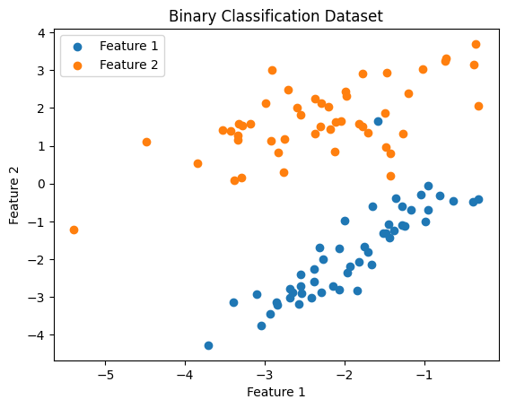

perceptron = Perceptron(input_size=2)  
perceptron.train(inputs, labels, num_epochs=10)  
x_min, x_max = inputs[:, 0].min() - 1, inputs[:, 0].max() + 1  
y_min, y_max = inputs[:, 1].min() - 1, inputs[:, 1].max() + 1  
xx, yy = np.meshgrid(np.arange(x_min, x_max, 0.1),  
 np.arange(y_min, y_max, 0.1))  
Z = perceptron.predict(np.c_[xx.ravel(), yy.ravel()])  
Z = Z.reshape(xx.shape)

plt.contourf(xx, yy, Z, alpha=0.3)  
plt.scatter(inputs[labels == 0][:, 0], inputs[labels == 0][:, 1], color='blue', label='Feature 1')  
plt.scatter(inputs[labels == 1][:, 0], inputs[labels == 1][:, 1], color='red', label='Featuer 2')  
plt.xlabel('Feature 1')  
plt.ylabel('Feature 2')  
plt.title('Perceptron Decision Regions')  
plt.legend()  
plt.show()

**Output:**

